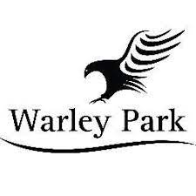

Code of Conduct for Parents/Carers of Young Golfers
As parents you are expected to:
- Positively reinforce your child and show an interest in their chosen activity
- Do not place your child under pressure or push them in to activities they do not want to do
- Be realistic and supportive
- Promote your child’s participation in playing sport for fun
- Complete and return the Player Profile Form and Consents pertaining to your child’s participation in activities at Warley park Golf Club
- Report and update Warley park Golf Club with any changes relevant to your child’s health and wellbeing
- Deliver and collect your child punctually before and after coaching sessions/competitions
- Ensure your child has clothing and kit appropriate to the weather conditions
- Ensure you child has appropriate equipment, plus adequate food and drink
- Ensure that you child understands the rules of Golf
- Teach your child that they can only do their best
- Ensure that your child understands their Code of Conduct
- Behave responsibly at Warley park Golf Club and on the golf course; do not embarrass your child
- Show appreciation and support the coaches, volunteers and staff at Warley park Golf Club
- Accept the decision and judgement of the officials during events and competition
As a parents/carer you have the right to:
- Be assured that your child is safeguarded during their participation in the sport
- Be informed of problems or concerns relating to your child
- Be informed if your child is injured
- Have consent sought for issues such as trips and photography
- Contribute to the decisions of the club
- Have any concerns about any aspect of your child’s welfare listened to and responded to
Any breaches of this code of conduct will be dealt with immediately by ……………………………. at Warley park Golf Club. Persistent concerns or breaches may result in you being asked not to attend games if your attendance is considered detrimental to the welfare of young participants.
The ultimate action should a parent/carer continue to breach the code of conduct may be the Warley Park Golf Club regrettably asking your child to leave the session, event or club.
Signed: | Date:
PRINT NAME:

