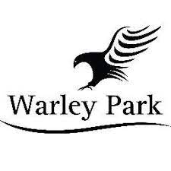

Code of Conduct for young Golfers

As a young golfer taking part in a Warley park Golf Club activity, you should:

- Help create and maintain an environment free of fear and harassment
- Demonstrate fair play and apply golf’s standards both on and off the course
- Understand that you have the right to be treated as an individual
- Respect the advice that you receive
- Treat others as you would wish to be treated yourself
- Respect other people and their differences
- Look out for yourself and for the welfare of others
- Speak out (to your parents or a club representative) if you consider that you or others have been poorly treated
- Be organised and on time
- Tell someone in authority if you are leaving the venue
- Accept that these guidelines are in place for the well-being of all concerned
- Treat organisers and coaches with respect
- Observe instructions or restrictions requested by the adults looking after you

You should not take part in any irresponsible, abusive, inappropriate or illegal behaviour which includes:

- Smoking
- Using foul language
- Publicly using critical or disrespectful descriptions of others either in person or through text, email or social network sites
- Consuming alcohol, illegal performance-enhancing drugs or stimulants
- Swimming or entering the lakes in any form.
- Taking any unnecessary risks to retrieve or attempt to retrieve golf balls or equipment from hazardous situations.

Child Signature Print Name

Parent/Carer Signature Print Name

